WINDOW CLEANER (EMPLOYEE) OF THE YEAR AWARD 2021
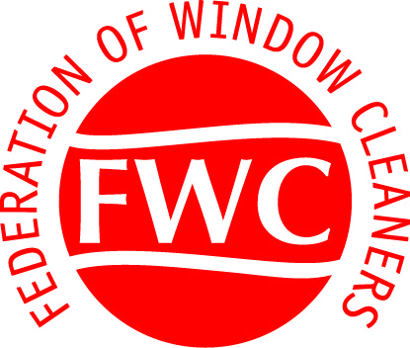

ENTRY FORM
this section should be completed by the MEMBER - on behalf of their nominated employee
Company trading Name:
Company Address: |  |  |  | Membership No:
 |  |  |  | Email:
 |  |  |  | Tel:
Date Company Established: |  |  |  | Mobile:
Essential to include any relevant client testimonials and training certificates with your entry

Nominated Employee:
Length of time employee has worked for this company |  |  |  |  | Length of time worked in the industry:
What is your reason for proposing this Employee – Max 100 words:
List any training & Qualifications:
Please include a photo of the candidate – this may be published in Window Talk with a list of contenders

SIGNATURE |  |  |  |  |  |  | DATE:
PLEASE RETURN COMPLETED FORM TO:
Federation of Window Cleaners- Summerfield House – Harrogate Road – Reddish –Stockport – Cheshire SK5 6HQ

Email: info@f-w-c.co.uk |  |  |  |  |  | Fax: 0161 947.9033
CONDITIONS OF ENTRY

This competition is open to all window cleaners who are registered members of the Federation of Window Cleaners; and all employees of registered members. Employees must have been nominated by their employer; and the relevant “Employee entry form” - only one employee per company is eligible to participate.

The competition will be judged by the General Secretary and three independent judges. The competition will have one category winner from each region - Judging will be based on industry achievements, time served and reasons for entering this competition: in addition to client testimonials, evidence of training, qualifications etc.
This competition is organized by the Federation of Window Cleaners.

CLOSING DATE FOR ENTRIES 31st JULY 2021

COMPETITION PRIZES

Each Regional winner of this competition will receive:

- Engraved Trophy

- Framed certificate

- £100.00 gift voucher.

- Success published in Window Talk & Social Media

Short-listed finalists will be informed prior to the event

Winners will be announced at the Cleaning Show – date to be confirmed in 2021.

